Diaominos
A roll-n-write for 1-4 players featuring a 2x2 puzzle cube.

Overview
Engineers have created equipment capable of crushing carbon into pure diamond over a 2-step process. You've acquired the tools and raw materials necessary to take advantage of this new technology.
To capitalize on this opportunity you must create specific diamond shapes before your rivals flood the market. The first production step generates polyomino shaped clusters with traces of diamond. Carefully align your clusters as you load them for the second step to generate the most in-demand shapes.

Components
Puzzle Cube
Game Board
Player Sheets

Setup
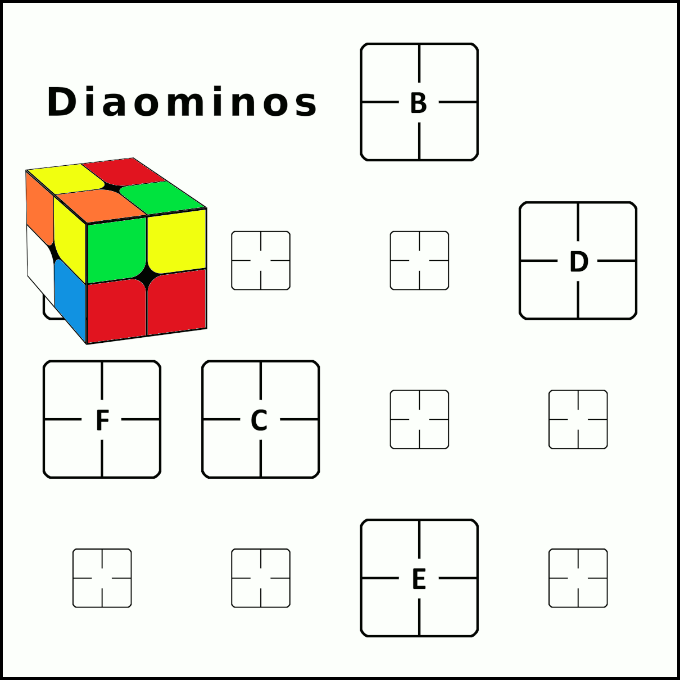
- Place the board in the center of the table.
- Scramble the puzzle cube, roll it and set it on the A space of the board.
- Players sit facing 1 side of the board and take a player sheet and pen.

- Players each then note on their sheets 1 of the 6 colors for each of their polyominos (use each color once); the 6th color is noted under the left-side grid and will be wild. Each player decides these for themselves.
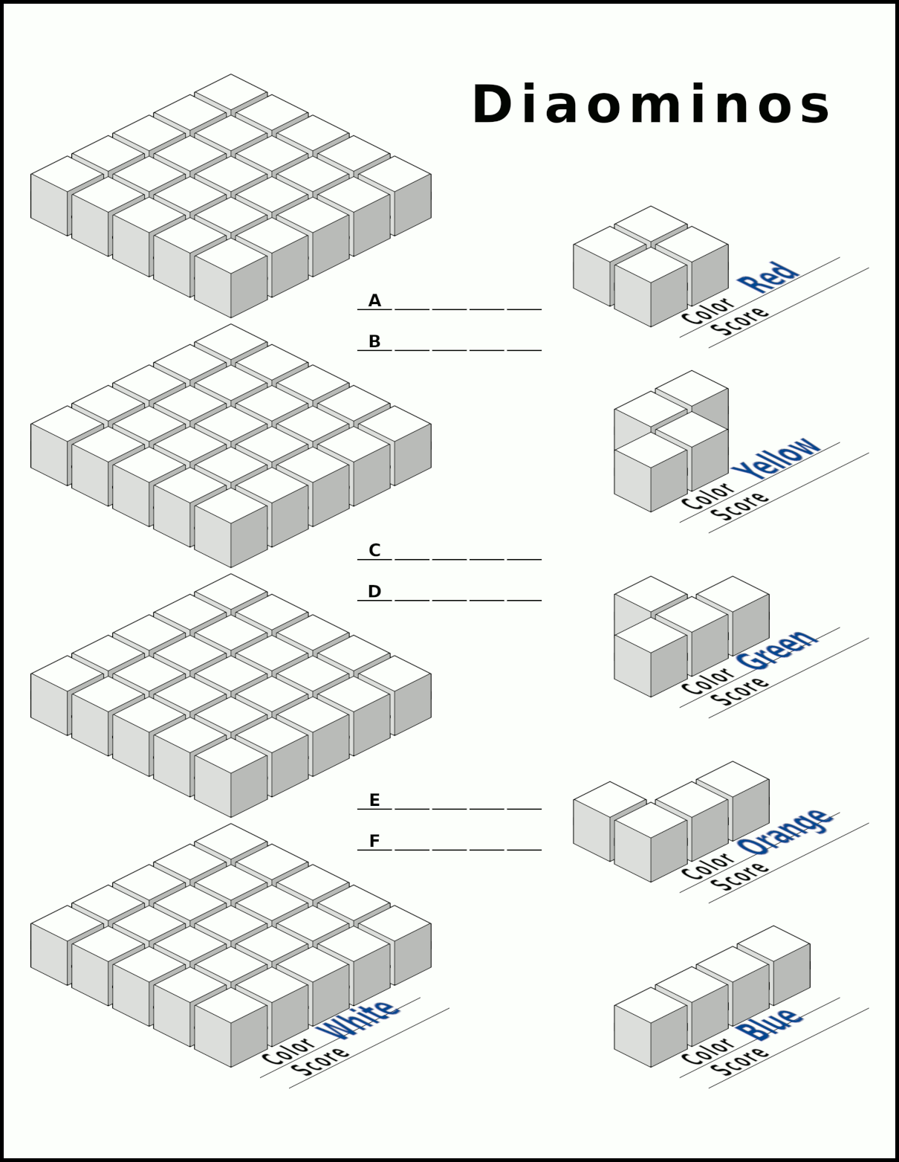

Game Play
Diaominos is played over 6 rounds. Players take their actions simultaneously during each round.

Rounds
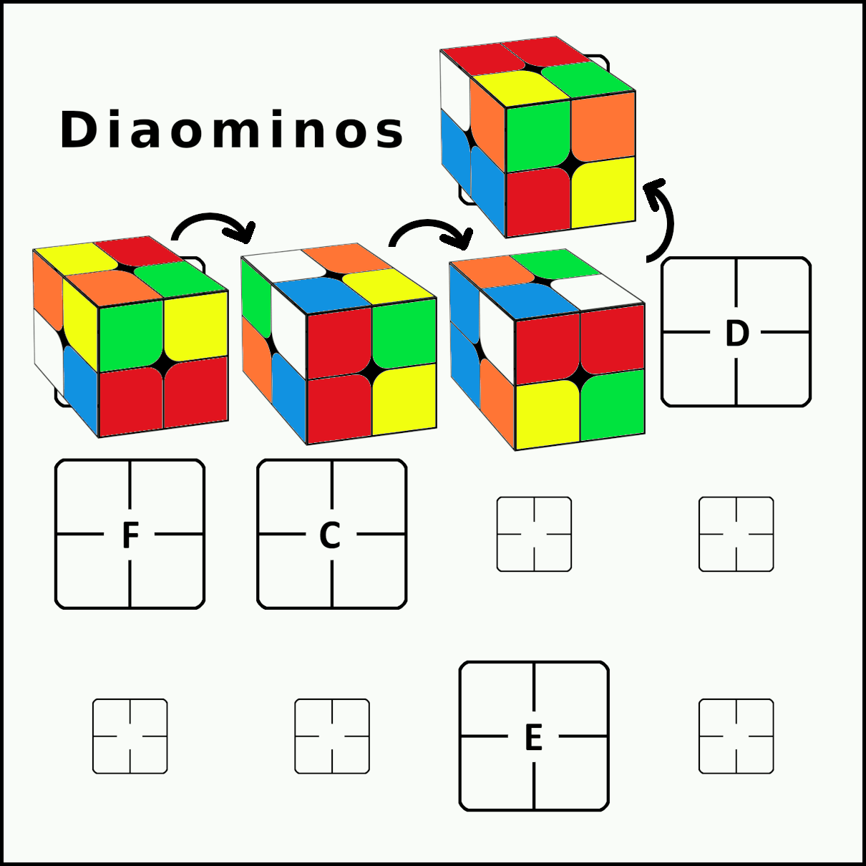
At the start of rounds 2-6 rotate the cube along the board to the next space in alphabetical order. The cube moves in an L shape with 2 spaces in 1 direction and then 1 space to the side. Rotate the cube in order to move it from space to space; do not slide it.
This rotation will cause each of the 6 surfaces to face upward once per game as well as face each of the players once per game.

Diamonds
After moving the cube players note the top 4 faces of the cube and mark a cube of the polyomino that matches each of those colors. Always mark the bottom-most (then right-most) unmarked cube.
Wild color faces allow marking any 1 cube in the large grid on the left side of the player sheet instead.
These marked cubes represent where diamonds will form in the grid when the polyominos are loaded into it.

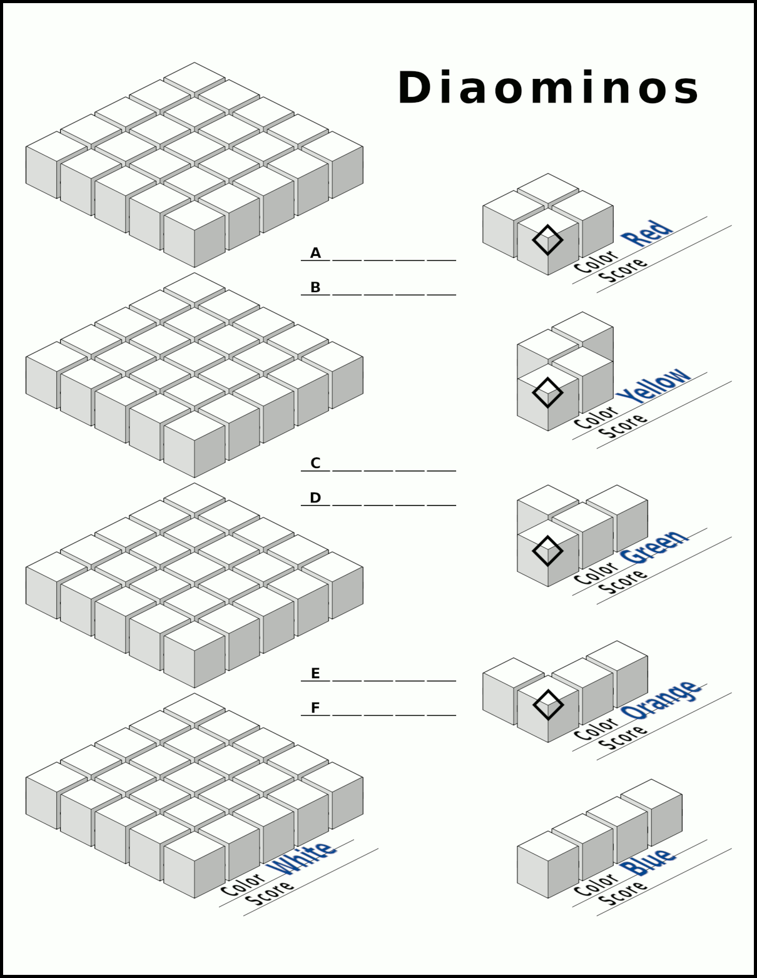

Loading
Players each note the 4 faces of the cube facing them individually and write their initials on the dashed row of their player sheet matching the current round.
Players then load these 4 polyominos into their grids crossing off the initial as they do to help keep track of which have been loaded for the round:
- Wild colors allow selecting any of the 5 polyomino shapes
- Polyominos may be rotated, flipped and mirrored when loaded
- Each newly loaded polyomino must be placed so that at least 1 of its cubes shares a face with an already loaded cube
- Skip loading any polyominos without sufficient space to fit in the grid
- Marked cubes in the polyomino cause the respective grid cubes to be marked as well
- Non-marked cubes instead fill in their respective cubes in the grid
- After loading a marked cube fill in the cube on that polyomino (each mark is loaded once per game)

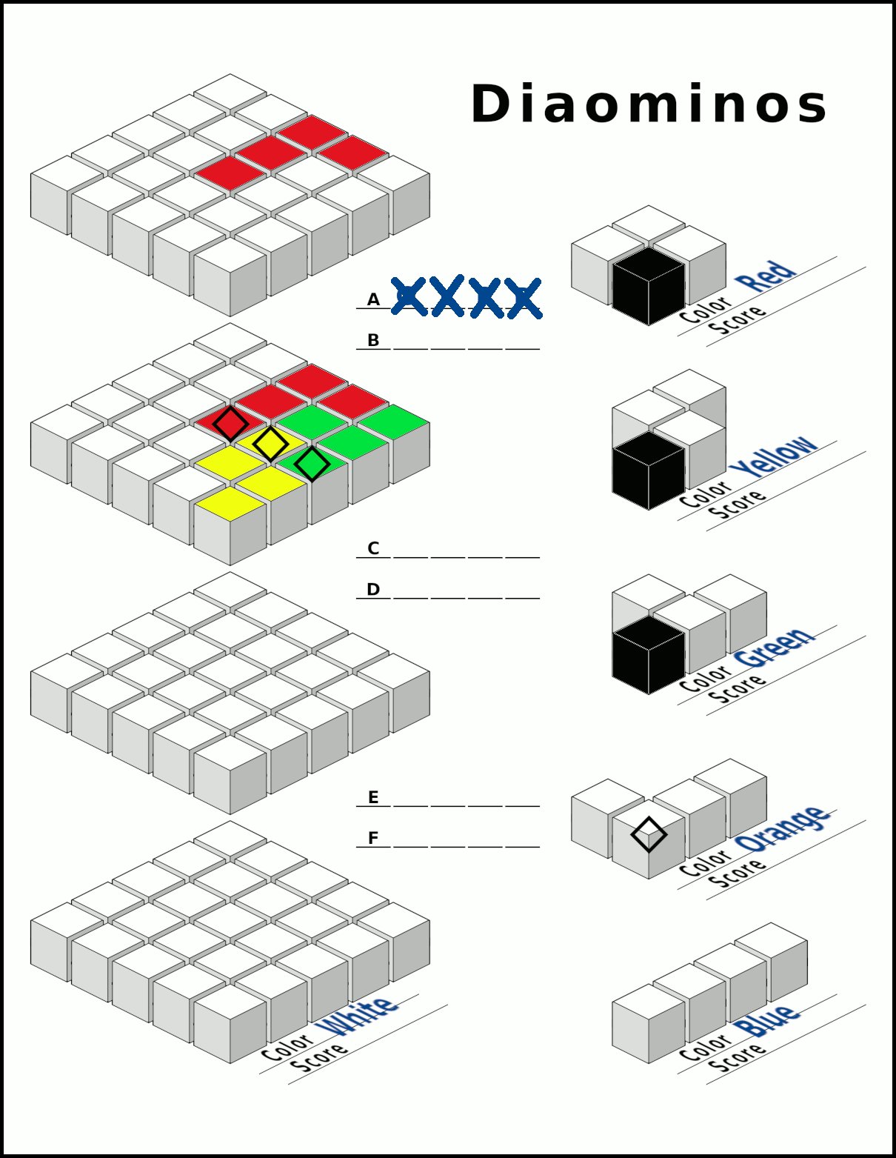

Scoring
Each time a player creates a polyomino entirely of diamond cubes they score 5 points noting it on the Score line under the matching polyomino. For each polyomino the first player overall to score that shape scores 1 additional point. Scored diamonds are then filled in just like the polyomino markings; each diamond cube may only be scored once per game.
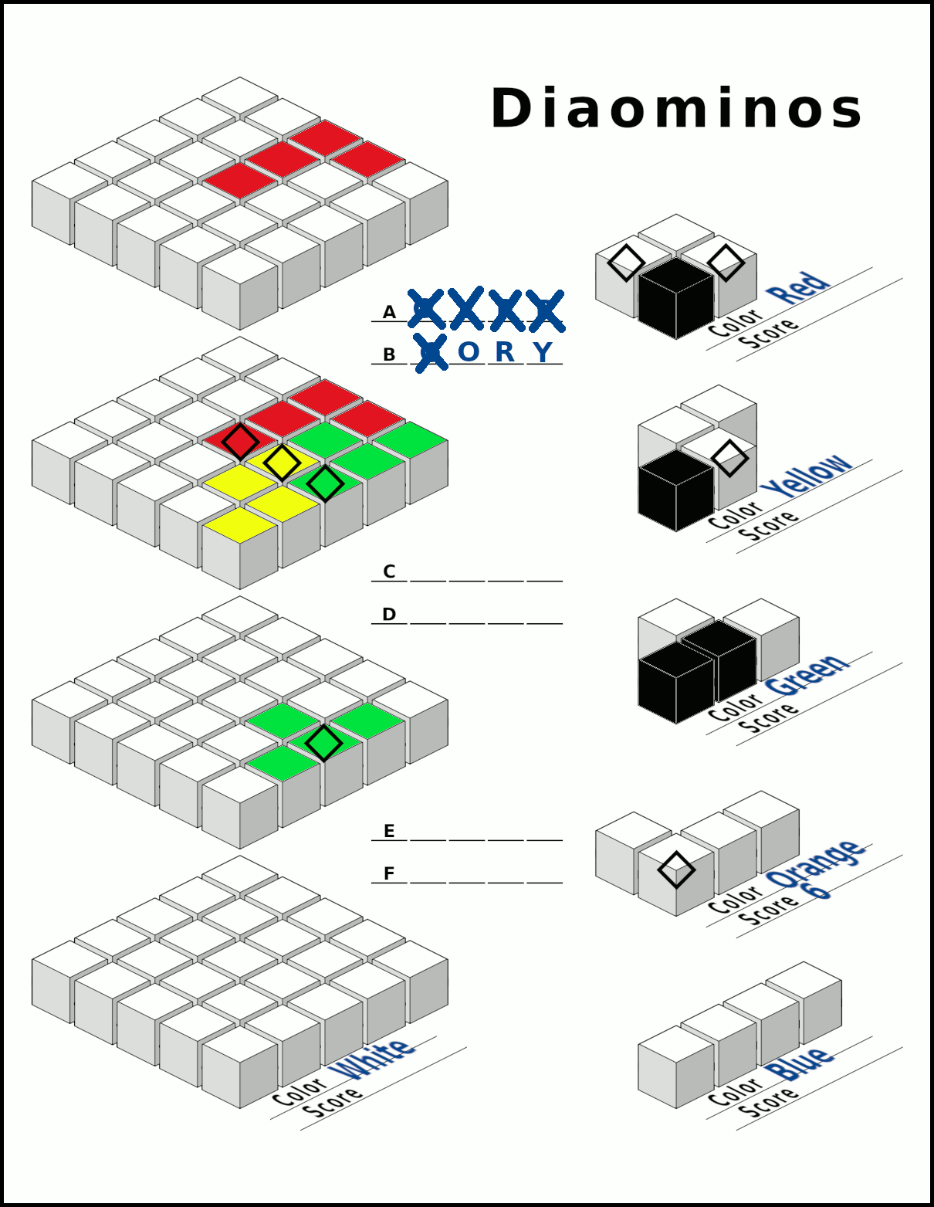

At the end of the game score 1 point for each grid layer the player completed as well as 1 point for each diamond mark remaining in the grid noting the total on the Score line beneath the wild color.
Players total their scores and the player(s) with the highest total wins.
